Rampant Guardant: Erect on his hind legs; full face; emblematic of prudence.
Rampant Reguardant: Erect on his hind legs; side face looking behind; emblematic of circumspection.
Saliant: The act of springing forward on its prey; emblematic of valour.
Sejant: Sitting, head in profile. Justice.
Sejant Erect: Sitting, rising to prepare for action; face in profile, tail erect; emblematic of counsel.
Sejant Affronté: (as in the crest of Scotland): majesty.
Statant: Standing with four legs on the ground; able for battle. With tail erect, ready for battle.
Couchant: Lying down; head erect, and tail beneath him; emblematic of sovereignty.
Coward or Coué: With tail hanging between his legs. Represents cowardice.
Dormant: Asleep, with head resting on his forepaws.
Passant: Walking, three feet on the ground; in profile; emblematic of resolution.
Passant Guardant: Three feet on the ground; full face. The "Lion of England" - resolution and prudence.
Passant Reguardant: Three feet on the ground; side face turned backwards.
Rampant: Erect on his hind legs; in profile; emblematic of magnanimity.

Colors | Sample | Suggested Meanings
Or  (Gold) |  | Generosity and elevation of the mind
Argent  (White/Silver) | 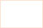 | Peace and sincerity
Gules  (Red) |  | Warrior or martyr; Military strength and magnanimity
Azure  (Blue) |  | Truth and loyalty
Vert  (Green) |  | Hope, joy, and loyalty in love
Sable  (Black) |  | Constancy or grief
Purpure  (Purple) |  | Royal majesty, sovereignty, and justice
Tenne  (Orange) |  | Worthy ambition
Sanguine  (Maroon) | 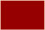 | Patient in battle, and yet victorious
Murrey  (Dark Purple) |  | Not Known
Proper  (Natural Colors) |  | Any charge depicted in it's natural colors

Furs
Ermine  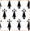 | White with black spots. Tinctures can not be changed.
Erminites  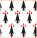 | White with black and red spots (black arrow shaped objects topped by red dots). Tinctures can not be changed.
Erminois  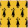 | Gold with black spots. Tinctures can not be changed.
Ermines  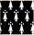 | Black with white spots. Tinctures can not be changed.
Pean  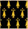 | Black with gold spots. Tinctures can not be changed.
Vair  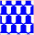 | A white field with blue bell-shaped objects. Tinctures can not be changed.
Counter Vair   | Version of Vair with bells placed facing. Tinctures can not be changed.
Vair en Point   | Version of Vair using the bells to form zig-zag lines. Tinctures can not be changed.
Vair in Pale   | Another version of vair with the bells stacked upon one another forming columns. Tinctures can not be changed.
Vairy of Four  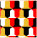 | Another version of vair with bells in Gules, Sable, White and Or. Tinctures can not be changed.
Potent   | Rowns of alternating T-shaped objects. Tinctures can not be changed.
Counter Potent   | T-shaped objects are stacked and placed facing. Tinctures can not be changed.
Potent en Point   | Version of Potent creating rough zig-zag lines. Tinctures can not be changed.
Fleury  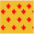 | Staggered Fluer-de-lis. Colors can be any combination of one metal color and one tincture.
Papellone  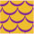 | Pattern of objects resembling fish scales. Colors can be any combination of one metal color and one tincture.
Plumete  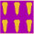 | Feather plumes stacked on top of each other. Can also be depicted staggered. Colors can be any combination of one metal color and one tincture.
Goutee  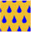 | Staggered pattern of drops. Colors can be any combination of one metal color and one tincture.

Heraldic Lines
Nebuly Line | Clouds or air
Wavy Line  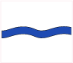 | Sea or water
Engrailed Line  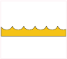 | Earth or land
Dovetailed Line  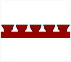 | Unknown
Invected Line  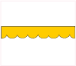 | Earth or land
Indented Line  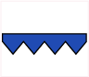 | Fire
Dancette Line  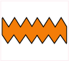 | Water
Raguly Line   | Difficulties that have been encountered
Embattled Line  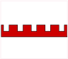 | Walls of a fortress or town (also, fire)
Crancelin  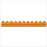 | Unknown

Ordinaries and Subordinaries
Bend  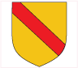 | Scarf or shield suspender of a knight commander; signifies defense or protection
Bend Cottissed  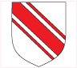 | Scarf or shield suspender of a knight commander; signifies defense or protection
Bend Sinister  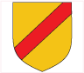 | Same as a Bend but placed in the opposite direction
Canton  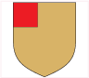 | As in a flag borne at the top corner of the shield; reward from the sovereign for performance of eminent service
Chevron  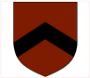 | Protection; Builders or others who have accomplished some work of faithful service
Chevron Inverted  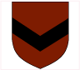 | Protection; Builders or others who have accomplished some work of faithful service
Chief  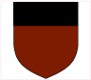 | Top one-third of the shield; signifies dominion and authority; often granted as a special reward for prudence and wisdom or successful command in war
Cross  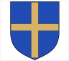 | Faith; service in the Crusades
Double Tressure  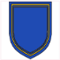 | Unknown
Fess  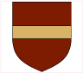 | Military belt or girdle of honour; represents readiness to serve the public
Fess Cottissed  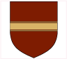 | Military belt or girdle of honour; represents readiness to serve the public
Flaunch  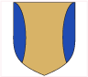 | Unknown
Gryon | Unknown
Pale  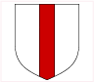 | Military strength
Inescutcheon  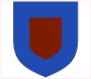 | Unknown
Pall or Shakefork  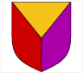 | unknown
Pall or Shakefork Inverted  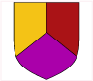 | unknown
Pile  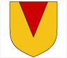 | Represents large pieces of wood used in building bridges; engineering skills, builder; May represent a pennon or flag
Tressure or Orle  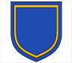 | unknown
Quarter  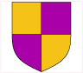 | No set meaning... this is simply a subordinary (a way to divide the field of a shield or lozenge/td>
Saltire | (St. Andrew's Cross) Resolution

Charges: | Suggested Meanings:
Acacia Branch  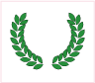 | Eternal and affectionate remembrance both for the living and the dead.
Acorn  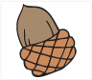 | Life, fertility, immortality and perseverence
Anchor  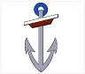 | Christian emblem of hope and refuge; awarded to sea warriors for special feats performed Also signifies steadfastness and stability. In seafaring nations, the anchor is a symbol of good luck, of safety, and of security
Annulet  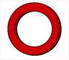 | Emblem of fidelity; Also a mark of Cadency of the fifth son
Antelope  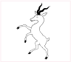 | Represents action, agility and sacrifice and a very worthy guardian that is not easily provoked, but can be fierce when challenged
Antlers  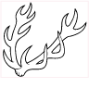 | Strength and fortitude
Anvil  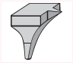 | Honour and strength; chief emblem of the smith's trade
Arrow  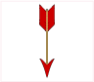 | Martial readiness; if with a cross it denotes affliction; a bow and arrow signifies a man resolved to abide the uttermost hazard of battle.
Ash Branch  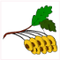 | ???
Axe (Battle)  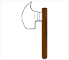 | Execution of military duty
Beacon  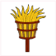 | one who is watchful, or who gave the signal in time of danger The modern sybol for this would be a lighthouse.
Bear  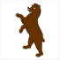 | royal emblem for the kingdoms of Persia and Russia, and the Celts considered the Bear the symbol of the great warrior
Bee  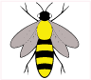 | Well-governed industry, resurrection, steadfastness and obedience
Bell  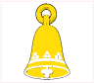 | Ritual
Billet  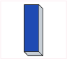 | denotes a man who obtained credence, knowledge and faith in his words and deeds and was secret in his affairs
Boar  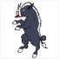 | Strength, courage, and ferocity
Boar Head  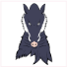 | Strength, courage, and ferocity
Book  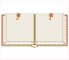 | If open, symbolizes manifestation; if closed, counsel
Bouget (Water)  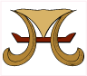 | A charge representing an ancient leather vessel used for carrying water to an army or to a besieged place. It consisted of a yoke with two leather pouches appended.
Bridge  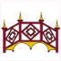 | Signifies the cares and patient stability of magistrates or governors, who must endure the assaults, taunts, and envy of the discontented and vulgar.
Buckle  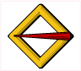 | Honourable bearing signifying affiliation, and victorious fidelity in authority
Bull  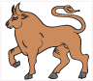 | Symbol of valour and magnanimity represents male fertility, a fiery temperament, and a role as the dedicated father.
Bull Head  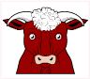 | Symbol of valour and magnanimity represents male fertility, a fiery temperament, and a role as the dedicated father.
Calla Lily  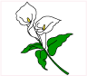 | ???
Caltrop | One who demonstrates ingenuity and resourcefulness when faced with a stronger foe
Cameopod  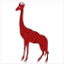 | ???
Canton  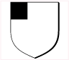 | A Subordinary-Bearing of honour; when borne charged, it often contains some very special symbol granted by the sovereign in reward for the performance of eminent service.
Castle  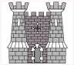 | The emblem of grandeur and society, and has been granted sometimes to one who has faithfully held one for his king, or who has captured one by force or strategy
Catherinewheel  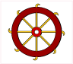 | Emblem of one who is prepared to undergo great trials for the Christian faith. It is a universal symbol of martyrdom.
Chough  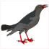 | one manifesting military stratagems to the great disadvantage of his enemies. It is also said the Cornish Chough indicates one who is watchful for friends and kindred.
Cinquefoil  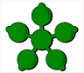 | A five-leafed flower signifying hope and joy
Clampirn   | ???
Clarion | ???
Cockatrice  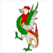 | Heraldic monster with the head, beak, comb, wattles and legs of a cock, a barbed tongue and the wings, tail and body of a wyvern. Terror to all Beholders
Cog  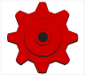 | ???
Coot  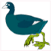 | The bearer of this device will use strategy rather than confrontation to achieve success.
Crane  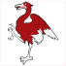 | Representative of long life, fidelity, grace, prosperity and peace.
Crescent   | Said to signify one who has been enlightened and honoured by the gracious aspect of his sovereign; also a symbol of 'hope and greater glory'. Also used as a mark of cadency of the 2nd son
Crosier  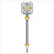 | The shepherd's watchfulness; Christian faith; pastoral authority; also Episcopal jurisdiction; service in the Crusades.
Cross   | ???
Crosslet  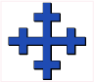 | ???
Cushion  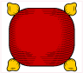 | They are considered marks of authority likely in reference to their popular use in royal chambers and ceremonies.
Dagger  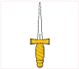 | A symbol of power, justice, valour and military honour.
Dolphin  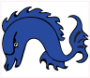 | charity and affection towards children and kindred. Also often used as a symbol for Christ
Dragon  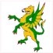 | Alchemy, the elements, eternal change, discovery of hidden treasures and the protector of all you possess.
Eagle  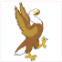 | noble device signifying a person of action, ever more occupied in high and weighty affairs, and one of lofty spirit, ingenious, speedy in apprehension, and judicious in matters of ambiguity; true magnanimity and fortitude of mind; a symbol of power and sovereignty. The Eagle also symbolizes courage, freedom, and immortality.
Eagle (Two Headed)  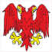 | See Eagle
Elephant  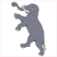 | Great strength, greater wit and greatest ambition.
Escarbuncle  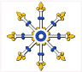 | Supremacy and dominence.
Estoile   | Celestial goodness, a man of noble personage. The estoile, is as a rule represented of six points and wavy. Estoiles sometimes occur with a greater number of points, as eight, or sixteen.
Falcon  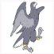 | A venerable symbol of majesty and power, heraldic writers add that the Falcon denotes someone eager, or hot in the pursuit of an object much desired; if seated on its 'rest' or perch it may signify a bearer who is ready and serviceable for high affairs.
Fasces  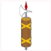 | Symbolizes strength that is lacking in the single rod. The axe symbolizes authority and leadership.
Fetterlock  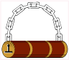 | A 'handcuff,' or prisoners' bolt. Signifies victory; one that has taken prisoners or rescued prisoners of war.
Fleam  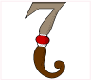 | Representing an ancient lancet or bloodletting instrument; the fleam of St. Luke, denoting that the bearer may have been a physician. (A fleam is a sharp lancet, which was used to open veins).
Fox  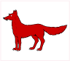 | Signifies one who will use all that he may possess of wisdom and wit in his own defence, and denotes one of strategic talents and fertility of resources.
Fret  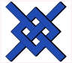 | Honourable bearing, symbolizing persuasion, and often granted to commanders for valiant service to their sovereign in a great war or battle;
Fusil  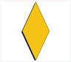 | Denotes laboriousness; always with work in hand.
Galley  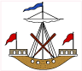 | Notable expedition by sea; One who engages in either war or commerce by sea
Garb  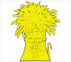 | The harvest of one's hopes had been secured. Also a symbol of hospitality and prosperity.
Greyhound  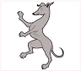 | Denotes majesty, courage, vigilance, swiftness and loyalty, and they were emblematic of nobility.
Goat  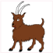 | One who wins through politics and wit rather than war and confrontation; Perseverance and vitality
Golden Fleece  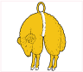 | Ancient honour from the Knightly Order of the Golden Fleece.
Griffin  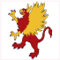 | Ideal combination of swiftness, strength and intelligence. Historically the Griffin has been emblematic of valour, vigilance and death defying bravery.
Holly  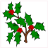 | Indicates directed balance and vigour to fight if the cause is just; symbol of truth.
Horse  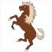 | Symbol of strength, virility and lust; Also a symbol for loyalty and devotion, such as the faith it has with its master; warrior spirit, bravery and courage.
Label   | Mark of cadency for the first son
Ladder  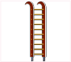 | Denotes one who was fearless in attacking; used in warfare only by extremely brave soldiers; when born up against a tower, it symbolizes awareness to stand carefully on guard as the castle is continually assailed by our spiritual and corporal enemies.
Lamb  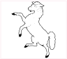 | An emblem of the Redeemer; symbolizes gentleness, innocence, and purity; sacrifice. In Christian symbolism, the lamb represents Jesus, "the lamb of God". Standing with a banner, the lamb represents the risen Christ triumphant over death (see Paschal Lamb). It is said when the lamb is resting on a book, it represents the judgment of Christ.
Laurel Branch | Peace and quietness
Leopard  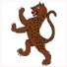 | represents those brave and generous warriors who have performed some bold enterprise with force, courage, promptitude, and activity.
Lion  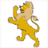 | Emblem of majesty, strength, and justice, military might and deathless courage
lymphad  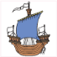 | See ship
Maple Leaf  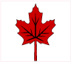 | ???
Martlet  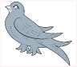 | One who had to subsist by virtue and merit, not inheritance; also denotes promptness. Mark of Cadency and was used as the symbol of the fourth son
Mascle  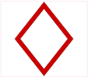 | A lozenge that is perforated or voided. Mascles represent the links that composed chain armour and may also represent the mesh of a net. If shown to represent a mesh of net it denotes persuasion; if shown to represent the links in chain armour it denotes protection.
Mermaid  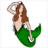 | A symbol of eloquence and an emblem of enlightenment it also represented a safe-voyage.
Paschal Lamb  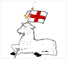 | Holy lamb is depicted passant, carrying a flag charged with the cross of St. George, and a circle of glory over its head. It is a symbol of faith, innocence, bravery, gentleness, purity, and resolute spirit.
Peacock  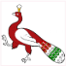 | Sacred to Hera (Juno), daughter of Titans Cronus and Rhea, wife and sister of Zeus. Medieval symbol of the soul, signifying beauty, power, and knowledge and is also a religious symbol of resurrection.
Pegasus  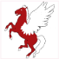 | Symbolic of poetic genius and inspiration, vision and refinement.
Pelican  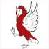 | Christian symbol of charity and sacrifice. if shown feeding her young ("in her piety"), it symbolizes filial love.
Pheasant  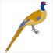 | An alert person of many resources.
Pheon  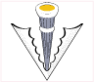 | Denotes dexterity and nimble wit; readiness for battle.
Phoenix  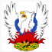 | Symbolizes the rising and setting of the sun, as well as immortality, resurrection, and life after death.
Plume (Feather)  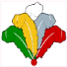 | Ostrich feathers. When three or more occur, they are termed a plume or in French, a panache. When more than three heights (rows) occur, the term pyramid of feathers is used. Denotes willing obedience and serenity.
Portcullis  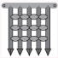 | Symbol of security and protection.
probiscides  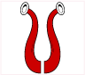 | Elephant trunks; usually represented in pairs; the elephant symbolizes longevity, strength, royalty, dignity, patience, wisdom, happiness, and good fortune.
Quartrefoil  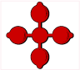 | ???
Rabbit (Hare)  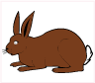 | ???
Ram  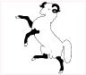 | Symbol of fecundity and rebirth.
Raven  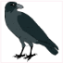 | Symbol of initiation, protection, and prophecy.
Rose  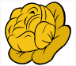 | Symbol of motherhood and purity. When shown stalked and leaved it has the added symbolism of protection because of the thorns.
Rose (Heraldic)  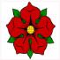 | See Rose
Scales  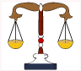 | Justice, order and balance
Sceptre  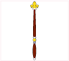 | symbol of kingship and is also a religious symbol of temporal power; throughout the ages borne to represent sovereignty and dominion.
Scythe  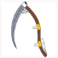 | Hope of a fruitful harvest.
Seahorse  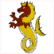 | ???
Serpent  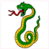 | Symbol of wisdom, cunning and sagacity.
Shacklebolt  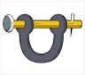 | See Fetterlock
Shamrock (Trefoil)  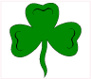 | Denotes omnipotence, providence and perpetuity; has been associated with good fortune and luck. Also the national symbol of Ireland. The trefoil ia a three-leaved figure usually slipped at the base and symbolic of perpetuity.
Ship/Galley  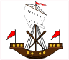 | Notable expeditions by sea, by which the first bearers had become famous. An honourable mariner’s bearing, symbolic of commerce, travel, initiation and warfare
Spear/Pike/Lance  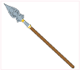 | See Pikev
Spider  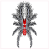 | Tenacity of purpose, heedfulness, and cunning.
Seastag  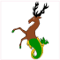 | Wisdom, regeneration and growth, and virility. Because its antlers resemble branches, the Stag has been associated with the 'Tree of Life' and because of the way it renews its antlers, it is used as a symbol of regeneration.
Stag  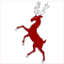 | Wisdom, regeneration and growth, and virility. Because its antlers resemble branches, the Stag has been associated with the 'Tree of Life' and because of the way it renews its antlers, it is used as a symbol of regeneration.
Star  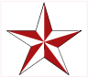 | Symbol of truth, the spirit and of hope; its meaning depends upon the number and sometimes the orientation of its points. It is the ensign of knightly rank; a star of some form constitutes part of the insignia of every order of knighthood. The star is the "presence of the divinity". It is a symbol of constancy, celestial goodness and a noble ensign.
Stork  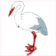 | Emblem of immortality and longevity, vigilance, contemplation, prudence, piety, meditation, and chastity.
Sun  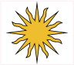 | Power, glory, illumination, vitality, and the source of life on earth. Symbolism also applies to a single sun ray. Most often depicted in it's splendour (glory)
Swan  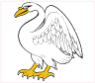 | Emblem of chivaldry; Represents music and poetry, especially that which is divinely inspired, passionate or tragic.
Sword  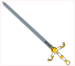 | Power, protection, authority, strength, and courage. It is a symbol of knighthood and chivalry.
Talbot  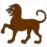 | One of courage and forecast, vigilance and loyal fidelity.
Thistle  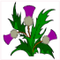 | The Order of the Thistle represents the highest honour in Scotland, and it is second only in precedence to the Order of the Garter; Symbol of independence, strength, protection and healing.
Tiger  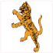 | Symbolic of royalty, power, and fearlessness, and was known to be dangerous if aroused.
Torch  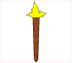 | Illumination, enlightenment, and guidance; often referred to as the torch of learning.
Tortoise  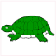 | symbol of longevity, patience and practicality; strength and time. It is also one of independence because it takes its home with it and is well protected.
Tower  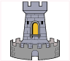 | The emblem of grandeur and society. See Castle.
Tree  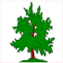 | ???
Trident  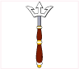 | Seniority and supremacy by sea.
Tulips  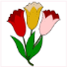 | ???
Unicorn  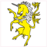 | Innocence and purity
Vine  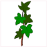 | Usually depicted as a grape vine, this charge symbolizes promise, frolic and bounty.
Violet  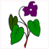 | ???
Vol  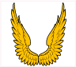 | ???
Vulture | Symbol of heaven and earth, spirit and matter, good and evil, a guardian and an avenger.
Water Bouget  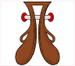 | See Bouget
Wheat  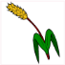 | See Garb
Willow Tree  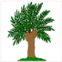 | symbol of beauty, grace, endurance and strength.
Wolf  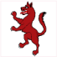 | Symbol of strength, intelligence and courage.

